Nicholas Skinner

CS321

Fall 2019

Homework 4

1. **Give context-free grammars that generate the following languages.**
   1. **L1 = { w ∈ {0, 1}∗ | w contains at least three 1s }**
      1. S -> A1A1A1A
      2. A-> 1A | 0A | **λ**
   2. **L2 = { w ∈ {0, 1}*| w = wR and |w| is even }**
      1. S-> 0S0|1S1|λ
   3. **L3 = { a^(i) b^(j) c^(k) | i, j, k ≥ 0, and i = j or i = k }**
      1. S-> AB | **λ**
      2. (ai = bj) A -> aAbC | **λ**
      3. (ai = ck) B-> aBcD | **λ**
      4. C - > c | **λ**
      5. D - > b | **λ**
2. **Consider the set of terminals T = {a, b, (, ), +, *, }. Construct a context-free grammar G=(V,T,S,P) that generates all strings in T* that are regular expressions over = {a, b}. Use the grammar to derive the regular expression (a+b)*.**
   1. So for our CFG G={V,T,S,P}
   2. Where V= {S}
   3. T = {a, b, (, ), +, *, Ø}.
   4. S = start variable
   5. P for production is:
   6. S-> a|b|(S)|S+S|SS| S*
   7. The derivation is: S->S* ->(S)* ->(S+S)* ->(a+S)* ->(a+b)*
3. **Consider the following grammar G = ({S, A}, {a, b}, S, P} where P is defined below**
   1. **Describe the language generated by this grammar.**
      1. Any string where there are a number of b’s equal to a multiple of 3, including null
   2. **Give a left-most derivation for the terminal string abbaba.**
      1. S =>AAA => aAAA => abAA =>abbA => abbaA => abbaAa => abbaba
   3. **Show that the grammar is ambiguous by exhibiting two distinct derivation trees for some terminal string**

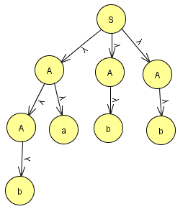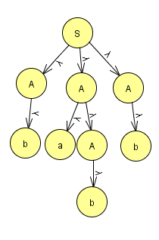

* 1. **If this language is regular, give a regular grammar generating it. If the language is not regular, prove that it is not.**
     1. S -> bA | aC | **λ**
     2. A -> bB | aA
     3. B -> bS | aB
     4. C -> bA | aC

1. **Find an s-grammar for L = {a^(n) b^(n+1): n >= 1 }.**
   1. G = ({S, A, B}, {a, b}, S, P)
   2. We have the following productions :
   3. S ->aAB,
   4. A -> aAB|b
   5. B -> b
2. **Let L = { a^(n)b ^(n) : n >= 0 }**
   1. **Show that L^(2) is a context-free language.**
      1. S-> ASB | **λ**
      2. A-> a
      3. B-> b
   2. **Show that L* is a context-free language.**
      1. L is context free, and we must now prove l* is the same, l* is created by:
      2. S->A S | λ
      3. A-> aAb|λ
      4. L is generated by G=(v,t,p,s)
      5. Define cfg, G that generates the L* as:
      6. G=({S},T,{S->SA|λ} , S}
      7. Each word is in either λ or sequence of word is in g
      8. So every word of l* can be generated by our G